Curriculum Vitae
MARY M. FLAHERTY, Ph.D.

Department of Speech and Hearing Sciences
University of Illinois
Champaign, ll. 61820
Phone: 217-300-8336
Email: maryflah@illinois.edu

- Personal History and Professional Experience

- Educational Background

University of Pittsburgh-Johnstown, B.S., Psychology, 2007
State University of New York at Buffalo, M.A., Psychology, 2013
State University of New York at Buffalo, Ph.D., Cognitive Psychology, 2016
Boys Town National Research Hospital, Postdoctoral Fellowship, 2018

- Academic Positions since Final Degree

2018 – to present Assistant Professor, University of Illinois at Urbana-Champaign

- Other Professional Employment

2016-2018 Postdoctoral fellow, Boys Town National Research Hospital, Omaha NE
2012-2015 Graduate Student Lecturer, Department of Psychology, SUNY Buffalo, Buffalo, NY
2013-2015 Supervisor of Comparative Bioacoustics Laboratory, SUNY Buffalo, Buffalo, NY
2014-2015 Adjunct Lecturer of Psychology, Trocaire College, Buffalo, NY
2008-2009 Data Administrator & Clinical Research Assistant, UPMC Magee Women’s Hospital, Pittsburgh, PA

- Honors, Recognitions, and Outstanding Achievements

2021 Teacher Ranked As Excellent, SHS 385– Quantitative Reasoning, UIUC Spring 2021
2021 Teacher Ranked As Excellent, SHS 570 – Quantitative Reasoning, UIUC Fall 2020
2020 Teacher Ranked As Excellent, SHS 552 – Pediatric Audiology, UIUC Spring 2020
2018 Mentored Research Travel Award funded by National Institutes on Deafness and Other Communication Disorders, American Auditory Society
2017 NIH Pediatric Loan Repayment Program funding by National Institutes on Deafness and Other Communication Disorders
2016 Postdoctoral Fellow Travel Award, Association for Research in Otolaryngology
2016 Research Mentoring-Pair Travel Award, American Speech-Language-Hearing Assoc.
2016 Excellence in Teaching Award, SUNY Buffalo
2015 Excellence in Teaching Award, SUNY Buffalo
2014 Graduate Student Excellence in Teaching Award, SUNY Buffalo

- Invited Lectures and Invited Conference Presentations

None

- Offices Held in Professional Societies

None

- Editorships of Journals or Other Learned Publications

2021 Review Editor on the Editorial Board of Auditory Cognitive Neuroscience (specialty section of Frontiers in Psychology and Frontiers in Neuroscience)

- Grants Received

The University of Illinois Campus Research Board is funding “The talker voice familiarity advantage for school-age children” (starting January 2021 ending July 2022), providing $26,831 across the funding period.

Role: Principle Investigator

- Review Panels

None

- Publications and Creative Works

Doctoral thesis

Flaherty, M. M. (2015). The Role of Experience in the Use of Speech Cues by Budgerigars. Doctoral dissertation, State University of New York at Buffalo, Buffalo, New York.

Articles in Journals

Flaherty, M. M., Libert, K., Monson, B.M. (2021). Extended high-frequency hearing and head orientation cues benefit children during speech-in-speech recognition. Hearing Research, 406, 108230.

Flaherty, M. M., Buss, E., Leibold, L.J. (2021). Independent and combined effects of F0 and VTL differences for school-age children's sentence recognition in a two-talker masker. Journal of Speech, Language, and Hearing Research, 64, 206-217. https://doi-org.proxy2.library.illinois.edu/10.1044/2020_JSLHR-20-00327

Flaherty, M. M., Browning, J., Buss, E., & Leibold, L.J. (2021). Effects of hearing loss on school-age children’s ability to benefit from F0 differences between target and masker speech. Ear and Hearing, 42(4), 1084-1096.

*Flaherty, M. M., Buss, E., & Leibold, L.J. (2019). Developmental effects in children’s ability to benefit from F0 differences between target and masker speech. Ear and Hearing, 40(4), 927-937.

*Browning, J., Buss, E., Flaherty, M., Vallier, T., Leibold, L. J. (2019). Effects of adaptive hearing aid directionality and noise reduction on masked speech recognition for children who are hard of hearing. American Journal of Audiology, 1-13.

*Rose, J., Flaherty, M., Browning, J., Leibold, L.J., Buss, E. (2018). Pure-tone frequency discrimination in preschoolers, young school-age children, and adults. Journal of Speech, Language, and Hearing Research, 1-6.
*Buss, E., Flaherty, M. M., & Leibold, L. J. (2017). Development of frequency discrimination at 250 Hz is similar for tone and /ba/ stimuli. The Journal of the Acoustical Society of America, 142(1), EL150-EL154.
*#Flaherty, M., Dent, M. L., Sawusch, J. R. (2017). Experience with speech sounds is not necessary for cue trading by budgerigars (Melopsittacus undulatus). PlosOne, (12) 5, 1-20.

*Dent, M. L., Martin, A. K., Flaherty, M. M., Neilans, E. G. (2016). Cues for auditory stream segregation of birdsong in budgerigars and zebra finches: Effects of location, timing, amplitude, and frequency. Journal of the Acoustical Society of America, (139) 2, 674-683.

*Mullennix, J.W., Stern, S.E., Grounds, B., Kalas, R., Flaherty, M., Kowalok, S., May, E., & Tessmer, B. (2010). Earwitness memory: Distortions for voice pitch and speaking rate. Applied Cognitive Psychology (24) 4, 513-526.

Bulletins, Reports, or Conference Proceedings

*Flaherty, M. and Sawusch, J. (2013). How robust are lexical effects on phonetic categorization? Proceedings of the 21st International Congress on Acoustics (Vol. 19, No. 1, p. 060203). Montreal, Canada.

Abstracts

Flaherty, M.M., Libert, K. Monson, B.M. (2020). The role of extended high frequencies in children's speech-in-speech recognition. The Journal of the Acoustical Society of America, 148, 2580. https://doi.org/10.1121/1.5147159

Refereed Conference Papers and Presentations

Conference Presentations:
Oral presentations:

Flaherty, M.M., Libert, K. Monson, B.M. (2020). The role of extended high frequencies in children's speech-in-speech recognition. Presented as talk at the Acoustical Society of America “Acoustics Virtually Everywhere” Conference. November 2020.

Flaherty, M., Dent, M. L., Sawusch, J.R. (2017) Experience with speech sounds does not influence cue trading by budgerigars. Podium presentation at the 4th Annual International Symposium on Acoustic Communication by Animals, Omaha, NE, July 2017.

Poster presentations:

Price, R., & Flaherty, M.M. (2022) Does short-term implicit voice familiarization improve children's speech-in-noise recognition? Poster presented at American Auditory Society Scientific and Technology Meeting, Scottsdale, AZ, February 2022.

Flaherty, M., Arzuaga, B., Bottalico, P. (2021). The effects of face masks on speech-in-speech recognition for children and adults. Poster presented at 181st Meeting of the Acoustical Society of America, Seattle, WA, November 2021.

Flaherty, M.M. (2022) Children’s use of target/masker F0 contour differences during speech-in-speech recognition. Poster presented at International Speech-in-Noise (SpiN) Workshop 2022.

Bishop, D., Flaherty, M. M. (2021). Word recognition in school-age children with autism spectrum disorder. Poster presented at American Auditory Society Scientific and Technology Meeting, Virtual Event, March 2021.

Dorn, A., Libert, K., Flaherty, M., & Monson, B. (2020). Effects of extended high frequency cues on speech recognition in school-age children. Poster presented at University of Illinois at Urbana-Champaign Undergraduate Research Symposium, Urbana, IL, May 2020.

Flaherty, M. (2020) The effect of talker familiarity on children’s speech-in-speech recognition. Poster presented at American Auditory Society Scientific and Technology Meeting, Scottsdale, AZ, March 2020.

Flaherty, M., Calandruccio, L., Buss, E., Leibold, L. (2019) Children’s ability to benefit from target/masker differences in F0-contour. Poster presented at American Auditory Society Scientific and Technology Meeting, Scottsdale, AZ, February 2019.

Libert, K., Mendoza, K., Flaherty, M. (2019) Children’s ability to benefit from a mismatch in voice intonation patterns. Poster presented at University of Illinois at Urbana-Champaign Undergraduate Researchers Initiative Symposium, Urbana, IL, April 2019.

Flaherty, M., Leibold, L. J., Buss, E. (2018) Children’s ability to benefit from fundamental frequency and vocal tract length differences during speech-in-speech recognition. Poster presented at 175th Meeting of the Acoustical Society of America, Minneapolis Minnesota, May 2018.

Flaherty, M., Browning, J., Buss, E., Leibold, L. J. (2018) Target/masker differences in F0: Effects of age and hearing loss. Poster presented at American Auditory Society Scientific and Technology Meeting, Scottsdale, AZ, March 2018.

Rose, J., Flaherty, M., Browning, J., Leibold, L.J., Buss, E. (2018) Pure-tone frequency discrimination in preschoolers, school-age children, and adults. Poster presented at American Auditory Society Scientific and Technology Meeting, Scottsdale, AZ, March 2018.
Browning, J., Flaherty, M., Leibold, L. J., Buss, E. (2017) Integrated directionality and noise reduction: Effects on children’s masked thresholds. Poster presented at American Auditory Society Scientific and Technology Meeting, Scottsdale, AZ, March 2017.

Flaherty, M., Leibold, L. J., Buss, E. (2016) Effect of temporal asynchrony on children’s detection performance in a random-frequency, multi-tonal masking task. Poster presented at the International Congress on Acoustics Annual Meeting of the Acoustical Society of America, Honolulu, HI, November 2016.

Flaherty, M., Sawusch, J., Dent, M. (2015) Speech experience and cue trading in budgerigars. (Melopsittacus undulatus). Poster presented at the International Congress on Acoustics Annual Meeting of the Acoustical Society of America, Pittsburgh, PA, May 2015.

Carter, D., Tronolone, A., Cheruvil, A., Asif, K., Flaherty, M. & Dent, M. (2015). The role of speech experience on cue trading in parakeets. Poster presented at the SUNY Undergraduate Research Conference at The College at Brockport, SUNY. April 2015.

Dent, M. Neilans, E., Flaherty, M., Martin, A. (2013) Auditory scene analysis in budgerigars (Melopsittacus undulatus) and zebra finches (Taeniopygia guttata). Poster presented at the International Congress on Acoustics Annual Meeting of the Acoustical Society of America, Montreal, Quebec, June 2013.

Flaherty, M. and Sawusch, J. (2013) How robust are lexical effects on phonetic categorization? Poster presented at the International Congress on Acoustics Annual Meeting of the Acoustical Society of America, Montreal, Quebec, June 2013.

Flaherty, M. (2012) Auditory scene analysis in budgerigars and zebra finches. Poster presented at the Annual Behavior and Brain Sciences Symposium, SUNY Buffalo, Buffalo, NY. June 2012.

Flaherty, M., Neilans, E., Garcia, K., Dent, M. (2012). Auditory stream segregation of Conspecific and heterospecific sounds in budgerigars (Melopsittacus undulatus) and zebra finches (Taeniopygia Guttata). Poster presented at the Annual Research Meeting of the Association for Research in Otolaryngology, San Diego, CA. February 2012.

Flaherty, M. and Sawusch, J. (2010) Phoneme perception and the structure of lexical
neighborhoods. Poster presented at the Annual Psychonomic Society Meeting, Seattle, Washington, November 2010.

Stern, S., Mullennix, J., Flaherty, M., Grounds, B., Hutchison, E., & Steinhauser, E. (2008). Stereotypes of physically and speech disabled persons as detected with partially structured attitude measures. Paper presented at the International Congress of Psychology Conference, Berlin, July 2008.

Stern, S. E., Mullennix, J. W., Steinhauser, E. F., Horvath, D., & Flaherty, M. (2007). Partially structured attitude measures used to examine stereotypes of the disabled. Presented at the Society for Personality and Social Psychology meeting, Memphis, TN.

Flaherty, M., Hutchison, E., & Kowalok, S. (2007). Partially structured attitude measure of stereotypes of disabled? Is it valid? Poster presented at the 10th Annual Laurel Highlands Undergraduate Psychology Conference, Johnstown, PA, April 2007.

Stern, S. E., Mullennix, J. W., Steinhauser, E. F., Horvath, D., & Flaherty, M. (2007).
Partially structured attitude measures used to examine stereotypes of the disabled. Paper presented at the Society for Personality and Social Psychology Annual Meeting, Memphis, TN, January 2007.

Steinhauser, E., Flaherty, M., Cole, T., Horvath, D., & Davis, A. (2006). A pilot study: Systematic perceptions of stereotype bias on the disabled community. Poster presented at the 9th Annual Laurel Highlands Undergraduate Psychology Conference, Johnstown, PA, April, 2006.

- RESIDENT INSTRUCTION
- SUMMARY OF INSTRUCTION
- Descriptive Data

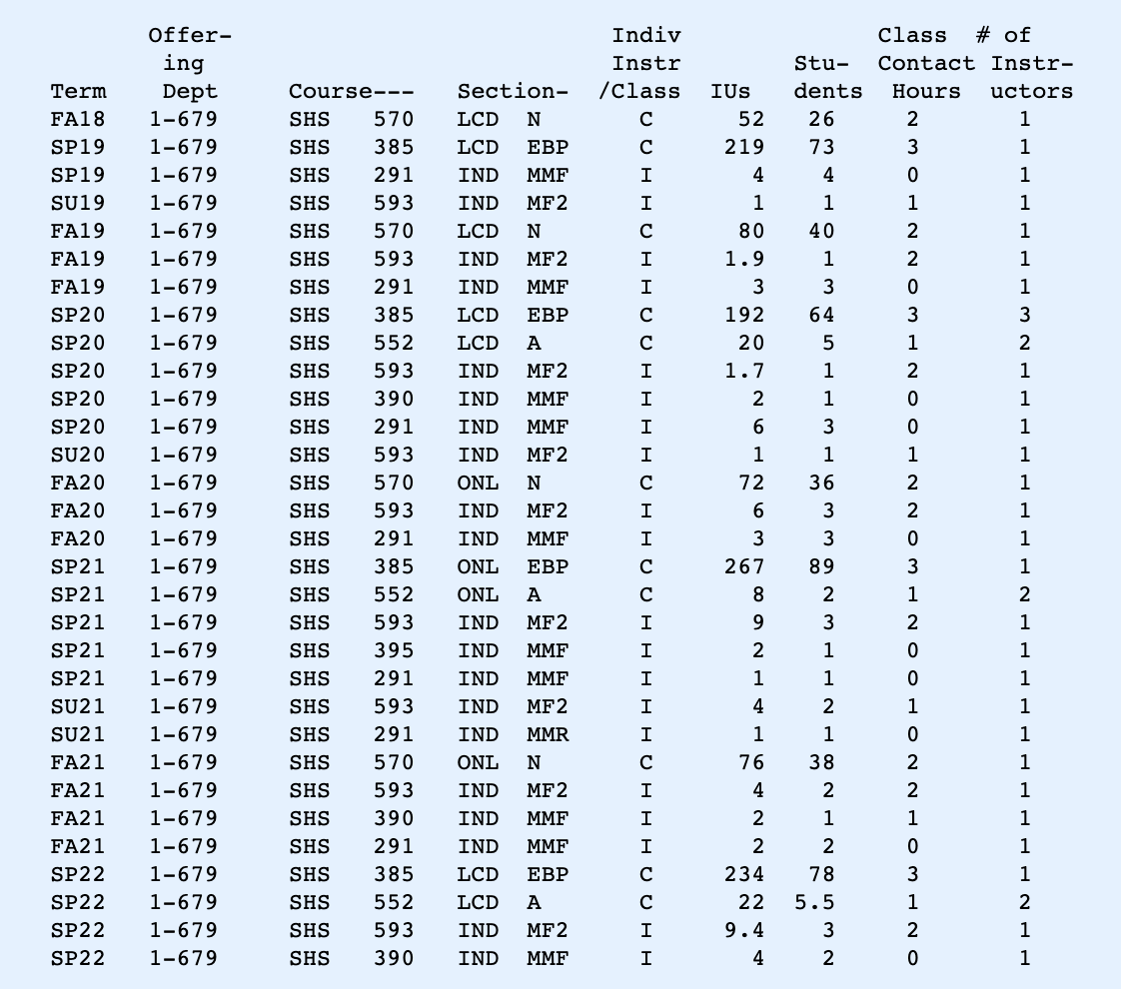
- Supervision of Graduate Students
DOCTORAL STUDENTS:
Chair, AuD Capstone
- Danielle Bishop, 2019-2021
Thesis: Effects of Autism Spectrum Disorder on Children’s Speech Perception in Noisy Environments. Expected graduation May 2022.
- Rachael Price, 2019-current. Talker Familiarity and Children’s Speech Recognition. Expected graduation: May 2023
- Briana Arzuaga, 2020-current. Influence of Face Masks on Children’s Speech-in-Speech Recognition Expected graduation: May 2023
- Campbell, Jillian 2020-present, Title TBD, current graduate student (exp. graduation 2024)
- Choudhry, Bisma 2021-present, Title TBD, current graduate student (exp. graduation 2025)
- Aguilar, Tania 2021-present, Title TBD, current graduate student (exp. graduation 2025)
- Graves, Kaley 2021-present, Title TBD, current graduate student (exp. graduation 2025)
- Oakes, Madison 2022-present, Title TBD, current graduate student (exp. graduation 2025)

PhD Research Committees
- Yihsin Tai, 2018-2020. Investigating the relationship between cognitive control and speech-in-noise recognition in tinnitus from perceptual, neuroanatomical, and electrophysiological aspects.
- Murgia, Silvia, 2021- present

AuD Capstone Committees

- Zoe Dinger, 2019-2020, Measurement of the acoustic reflex using wideband tympanometry. Member of Capstone Committee.
- Ali Marquees, 2019-2021, Survey of Clinical Uses of Otoacoustic Emissions.
- Abigail Stutz, 2019-2021. Effects of noise exposure on performance in adults with normal hearing.
- Morgan Potocki, 2019-2021. Measurements of the contralateral suppression system in transient-evoked otoacoustic emissions and auditory steady-state responses.
- Rachael Piper, 2019-2021. Lombard Effect, Ambient Noise and Willingness to Spend Time and Money in a Restaurant Amongst Older Adults.
- Rojas, Raquel, 2019-2022, “The role of EHF hearing loss and masker head rotation in cocktail party listening,”
- Kristen Moore, 2021- present. Speech intelligibility in dining halls. Expected completion 2023
- Taylor Mekus, 2021- present. Classroom acoustics for enhancing students’ understanding when a teacher suffers from a hoarse voice. Expected completion 2023.
- Melanie Flores, 2021-present. Access To Speech During Development: A Comparison of Full-Term Vs. Preterm Infants

MASTER’S STUDENTS
- Megan Placko, Masters in Speech-Language Pathology, Year 1. Working on Funded Research Project: The talker voice familiarity advantage for school-age children. Research supervisor. January 2021-January 2022.

- Supervision of Undergraduate Students

Undergraduate Student Mentoring:
Current Lab Members:
- Kelsey Libert, undergraduate research assistant. From Spring 2018-present.
  - Co-authored manuscript published Spring 2021.
  - Co-authored posters: Acoustical Society of America 2020; Undergraduate Research Symposium, May 2020 & one accepted for April 2021.
- Amber Dorn, undergraduate research assistant. From Fall 2019-present.
  - Co-authored poster for Undergraduate Research Symposium, May 2020 & Honors Project in April 2022.

- Lisa Lemajeur, undergraduate research assistant. From Spring 2020-present.
  - Honors Project: Co-authored poster for Undergraduate Research Symposium, accepted for April 2021.
- Tau, Isabella, 2020-present, research assistant, SPARK student, freshman.
  - Co-authored poster for Undergraduate Research Symposium, Honors Project in April 2022.
- Yusuff-Akinbo, Zainab, 2020- present, research assistant, junior.
  - Co-authored poster for Undergraduate Research Symposium in April 2022.
- Russel, Maddie, 2022- present, research assistant, junior.
- Sama, Esha, 2022- present, research assistant, sophomore

Former Lab Members:
- Elysse Trevino, undergraduate research assistant. Fall 2020-Spring 2021
- Abby Lerman, undergraduate research assistant. Spring 2020-Spring 2020.
- Emily Pankey, undergraduate research assistant. Spring 2018-Spring 2020.
- Jasmine Thaakar, undergraduate research assistant. From Fall 2018-Spring 2020.
- Celeste Rodriguez, undergraduate research assistant. From Spring 2018-Fall 2020.
- Amanda Diaz, undergraduate research assistant. From Spring 2018-Spring 2020.
- Natalie Raden, undergraduate research assistant. From Spring 2018-Fall 2020.

James Scholar Honors Project Supervision:
- Sexton, Collin Spring 2022, Junior, SHS 385 James Scholar Project Supervision
- Dorn, Amber Spring 2022, Sophomore, SHS 385 James Scholar Project Supervision
Former James Scholar Students
- Arianna Bastys, Senior, Department of Speech and Hearing Science, AHS
- Kathleen Dowling, Senior, Department of Speech and Hearing Science, AHS
- Brianna Legner, Senior, Department of Speech and Hearing Science, AHS
- Mary Buchheit, Senior, Department of Speech and Hearing Science, AHS
- Mia Jayes, Senior, Department of Speech and Hearing Science, AHS

- Other Contributions
- Flaherty, M.M. (2019) Development of the Auditory Cortex. UIUC, SHS 541: Clinical Auditory Anatomy and Physiology, Guest Lecture.
- Flaherty, M.M. (2020) Development of the Auditory Cortex. UIUC, SHS 541: Clinical Auditory Anatomy and Physiology, Guest Lecture.
- Flaherty, M.M. (2020) The Importance of Matlab for Audiologists. UIUC, SHS 542: Signals and Systems, Guest Lecture.
- Flaherty, M.M. (2021) Development of the Auditory Cortex. UIUC, SHS 541: Clinical Auditory Anatomy and Physiology, Guest Lecture.

B. EVALUATION OF INSTRUCTION

Semester | Course # | Title | Role | Enrolled  (n = ) | ICES  #1 | ICES #2
Spring 21 | SHS385 | Evidence-Based Practice in CSD | Lecturer | 89 | 4.68 | 4.48
Spring 21 | SHS395 | Individual Honors Study | Supervisor | 1 | n/a | n/a
Spring 21 | SHS552 | Diagnosing Hearing Impairment in Infants & Children | Lecturer | 4 | 5.0 | 5.0
Spring 21 | SHS593 | Capstone Project | Supervisor | 3 | n/a | n/a
Fall 21 | SHS570 | Quantitative Reasoning in SHS | Lecturer | 37 | 4.5 | 4.1
Spring 22 | SHS385 | Evidence-Based Practice in CSD | Lecturer | 78 | TBD | TBD
Spring 22 | SHS395 | Individual Honors Study | Supervisor | 2 | n/a | n/a
Spring 22 | SHS552 | Diagnosing Hearing Impairment in Infants & Children | Lecturer | 11 | TBD | TBD
Spring 22 | SHS593 | Capstone Project | Supervisor | 3 | n/a | n/a

4. Service

- Public Engagement

- Service to Disciplinary and Professional Societies or Associations
- Full member of Acoustical Society of America, 2021-present
  - Co-chair and organize session at ASA Spring 2022 Meeting
  - Student poster judge ASA Winter 2021 Meeting
- Ad hoc reviewer for American Journal of Audiology, 2021-present
- Ad hoc review for Scientific Reports, 2021-present
- Ad hoc reviewer for Phonetica, 2021-present
- Review Editor for Frontiers in Psychology and Frontiers in Neuroscience, February 2021-present
- Ad hoc reviewer for Journal of the Acoustical Society of America, 2020- present
- Ad hoc reviewer for Ear and Hearing, 2019 – present
- Ad hoc reviewer for Animal Cognition, 2020 - present
- Ad hoc reviewer for Journal of Speech Language and Hearing Research, 2017- present
- Member of the American Auditory Society, 2017-present
- Associate Member of the Acoustical Society of America, 2015 - 2021
- Member of Association for Research in Otolaryngology, 2013-2017

- University/Campus Service
- UIUC Faculty Senate Fall 2021- present
- SHS AuD Teaching Faculty Search Committee, Spring 2022-present
- SHS AuD Clinical Faculty Search Committee, Spring 2022-present
- SHS Graduate Admissions, Fall 2020-present
- AHS Education Policy Committee, Fall 2020-present
- SHS Faculty Search Committee, Spring 2020
- SHS Awards Committee, Fall 2019-Spring 2020
- Departmental Education Policy Committee, Fall 2019-Spring 2021
- AHS Elections and Credential Committee, Fall 2019- Spring 2020

